HOW TO CONTACT US

Anna.jacobs@musictherapybedfordshire.co.uk

07850 914130

www.musictherapybedfordshire.co.uk

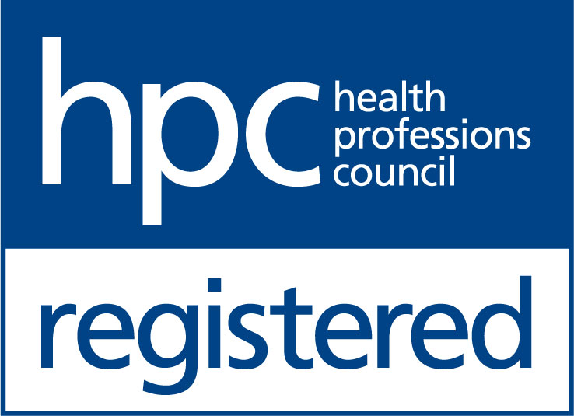

CRB checked

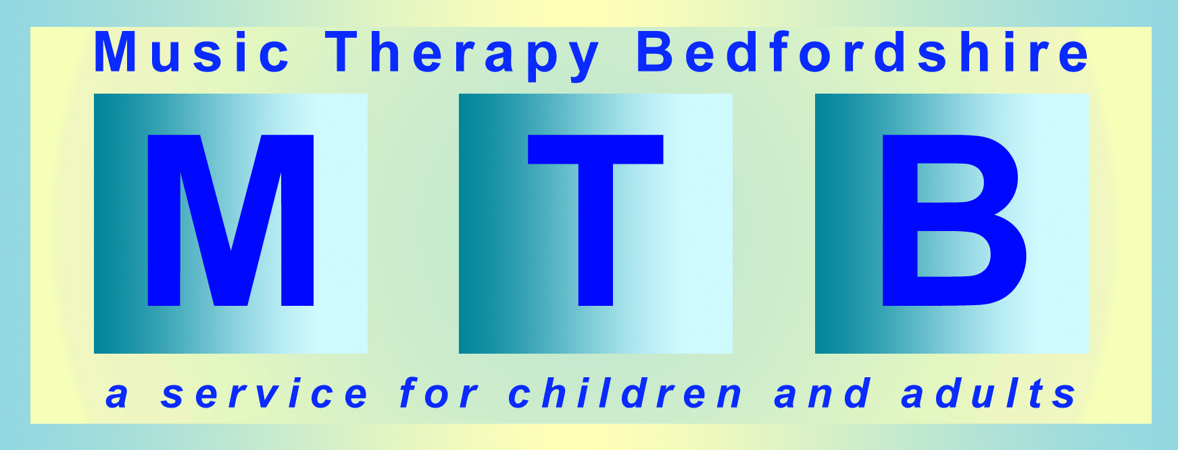

Music Therapy for Adults

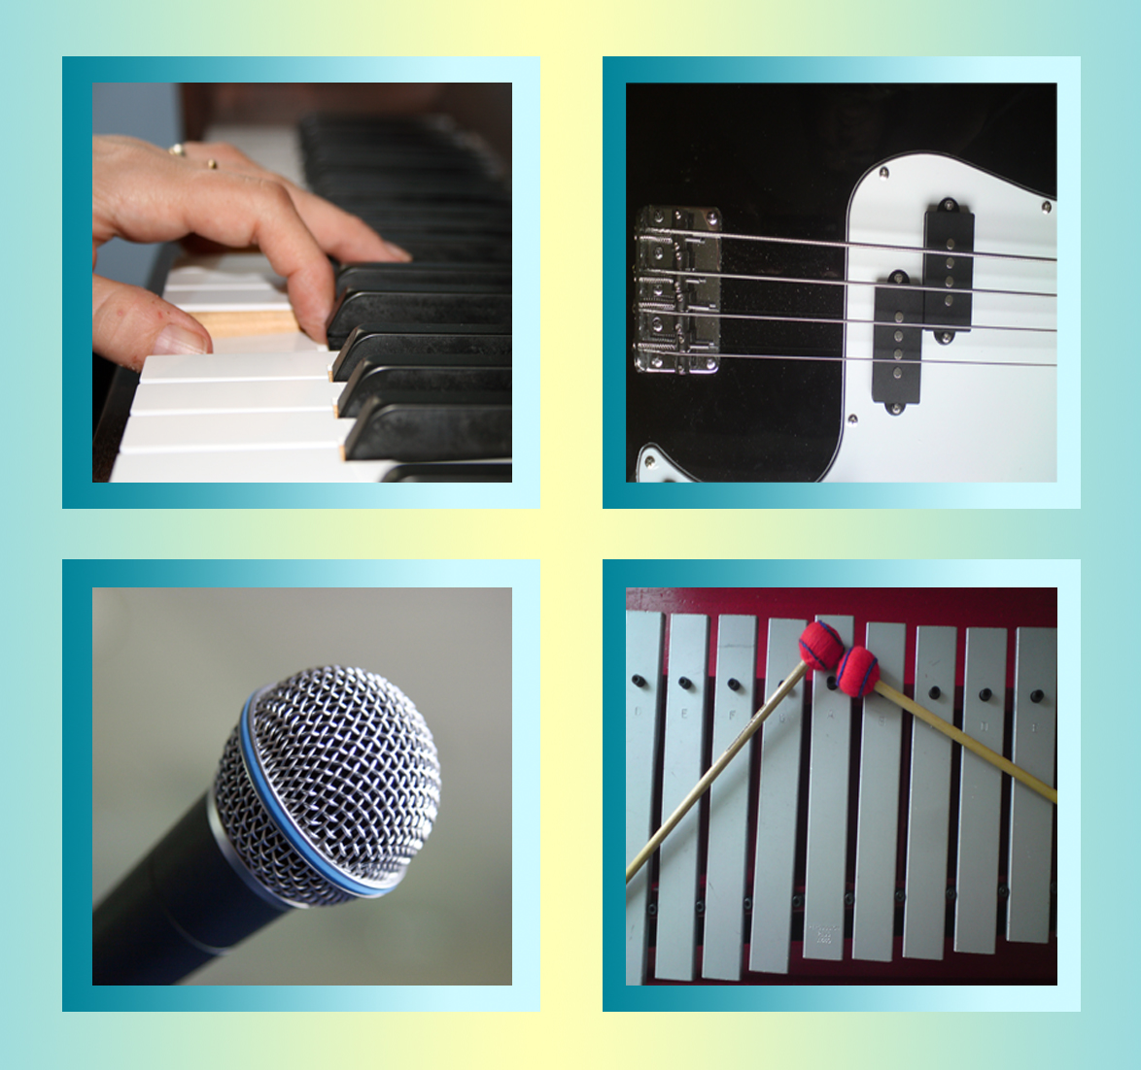

What happens in a music therapy session?

- You meet the music therapist in the therapy room at the same time each week.

- You choose instruments to play.

- The music therapist will support you.

- We will make up music together (improvise).

- We will listen to each other.

- You can choose to talk about the music we play together or to talk about anything else. There is no pressure

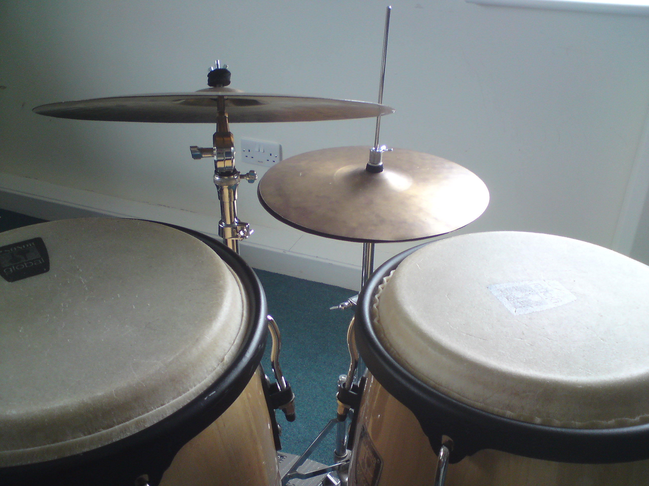

How will this help me?

Music therapists are trained to
listen very carefully to you.

Music therapists know how to use music to help with:

Social skills and talking

- Making up music is like talking without needing words.

- Music can be used to help you speak more clearly.

Emotions and feelings

- Making music can help you feel calm and relaxed.

- Making music can help you express your feelings.

- The therapist will help you share how you feel in your own way and in your own time.

- You may feel more confident after a session.
Coordination and movement

- Music can be used to help you move your fingers, arms, legs, head and body with more control.

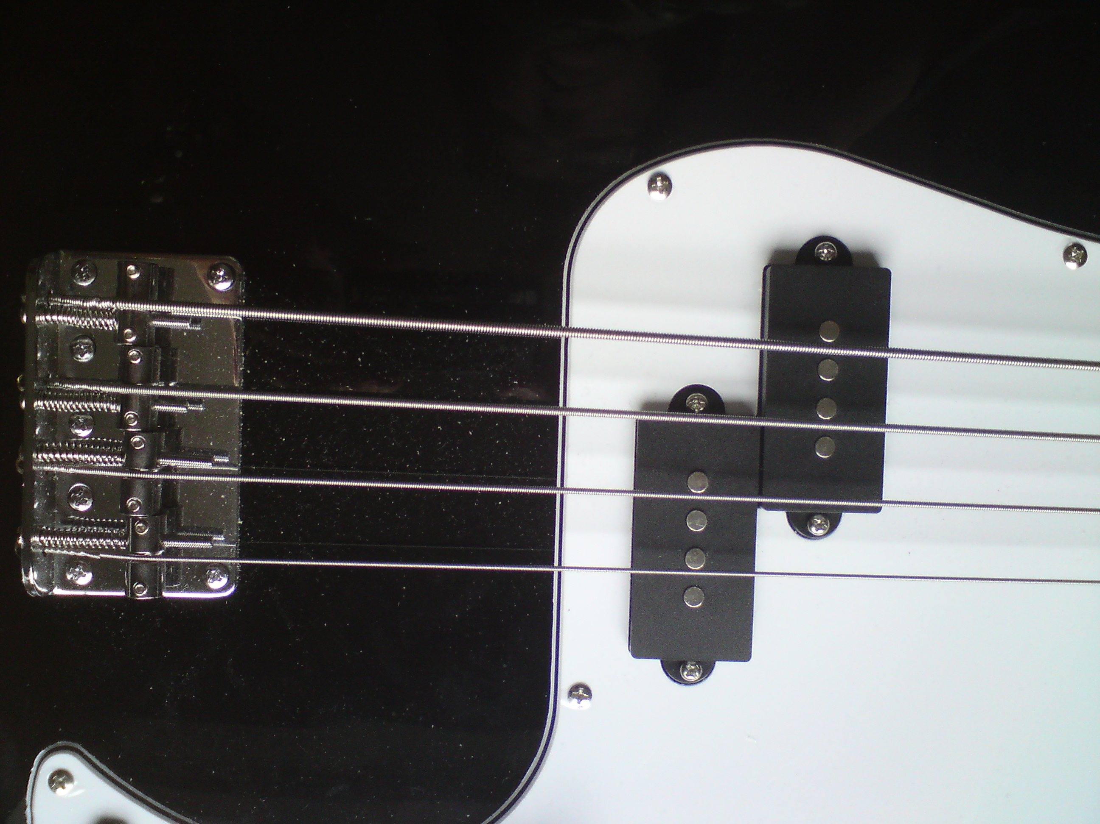

Thinking

- Music can be used to help you to concentrate, remember, choose and organise.

Will I notice any changes?

You may feel:

- More confident

- More relaxed

- More coordinated
- Less anxious

- Positive changes in your mood

- Your thoughts feel clearer

What if I feel worried?

We will work on this together. There is no right or wrong way to do music therapy. We will work at your speed and you can leave a session at any time if you feel uncomfortable.

What if I don’t like music or loud sounds?

You can choose what instruments to use and how loudly to play:

- Piano and keyboards
- Guitars
- Singing
- Wind instruments
- Bells, chimes
- Xylophones and glockenspiels
- Cymbals, drums, drum kits
- Small percussion
instruments

