HOW TO CONTACT

anna.jacobs@musictherapybedfordshire.co.uk

07850 914130

www.musictherapybedfordshire.co.uk

DBS checked

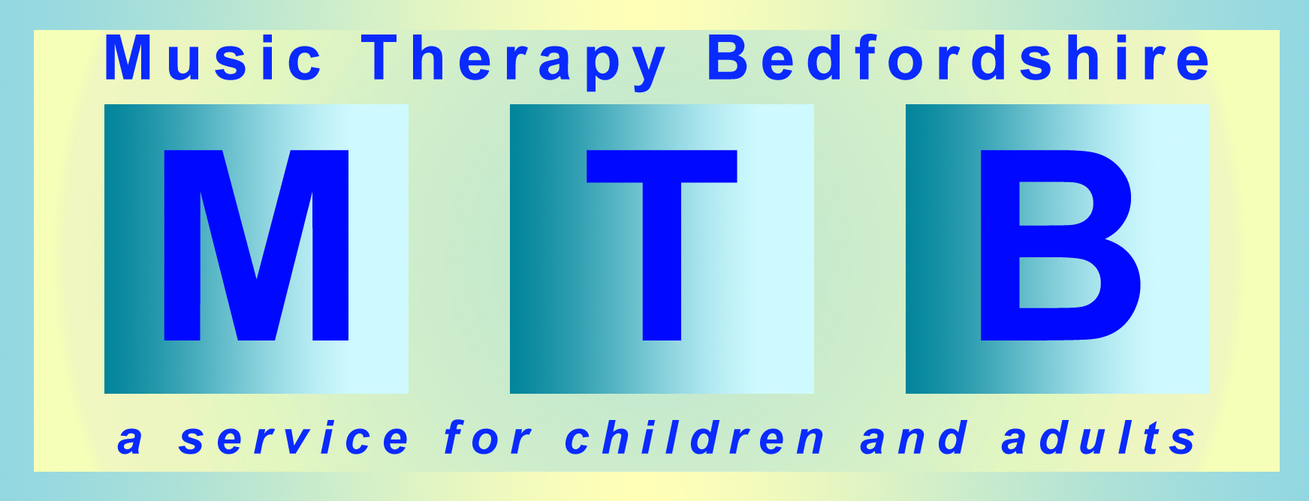

Guide for Service Providers

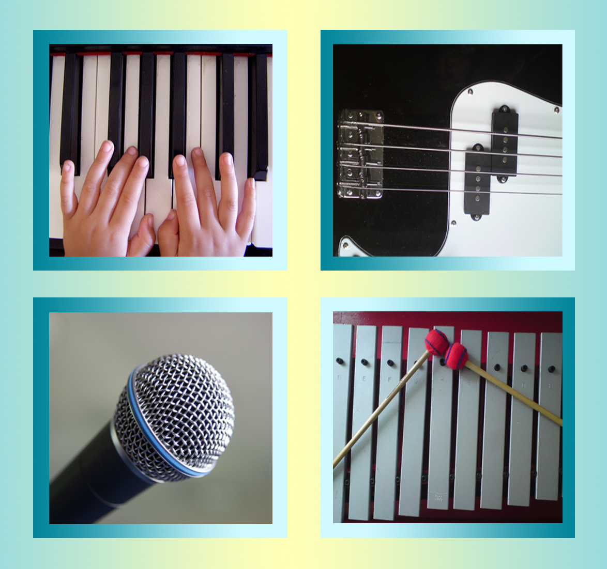

Contents:

- What is Music Therapy?

- What happens in a Music Therapy session?

- Music Therapy and mental health

- Music Therapy and neuro disability

- Music Therapy and social communication disorders

- Music Therapy and learning disability

- Music Therapy and multi sensory impairment

- What changes will be seen?

- Will clients enjoy Music Therapy?

- Where will it take place?

- Costs

- Referrals

‘This is the only therapy for his emotional and mental health-the only one that gives him a voice in a completely non-verbal world. Music therapists are experts, who can observe the smallest changes that tell us what is
happening in my son’s life’
(parent)

‘Music therapy is the main reason my son has progressed to speaking. Music makes a connection that nothing else could’
(parent)

‘Music therapists are in a unique position of coming in regularly enough to be able to offer insight, exactly when needed, to teachers of very disruptive pupils, because they know the child
and the school so well’
(senior teacher)

‘The sessions L had, gave
her personal quality time
with a sympathetic therapist who was able to lead her through displays of raw emotion and give her ways of dealing with aggression,
which did not involve self - mutilation as before.’
(carer)

11. How much does Music
Therapy cost?

Music therapy is not a ‘quick fix’ and as with any therapy, its effectiveness depends on sessions taking place regularly and over a suitable period of time. The work will be closely evaluated and outcomes will be measured.

Please note: This is a psychological therapy; it is not a recreational music
session nor an entertainment.

Our music therapists are highly qualified, skilled clinicians. All are HCPC registered, DBS checked, receive clinical supervision, keep clinical records ,use
video (with permission), and evaluate sessions.

Music Therapy Bedfordshire
is fully committed to developing evidence-based practice

Prices reflect this.

Cost for individual weekly sessions, £65 per session.

Group sessions are charged per client, depending on the size of the group. Please see our website for more details.
All fees include session preparation, report writing, clinical supervision and multi-professional liaison.
Service level guidelines are available.

12. How do I refer?

Referral forms are available to download from our website (details on back page).

There are two separate forms:

- Children and Young People

- Adults

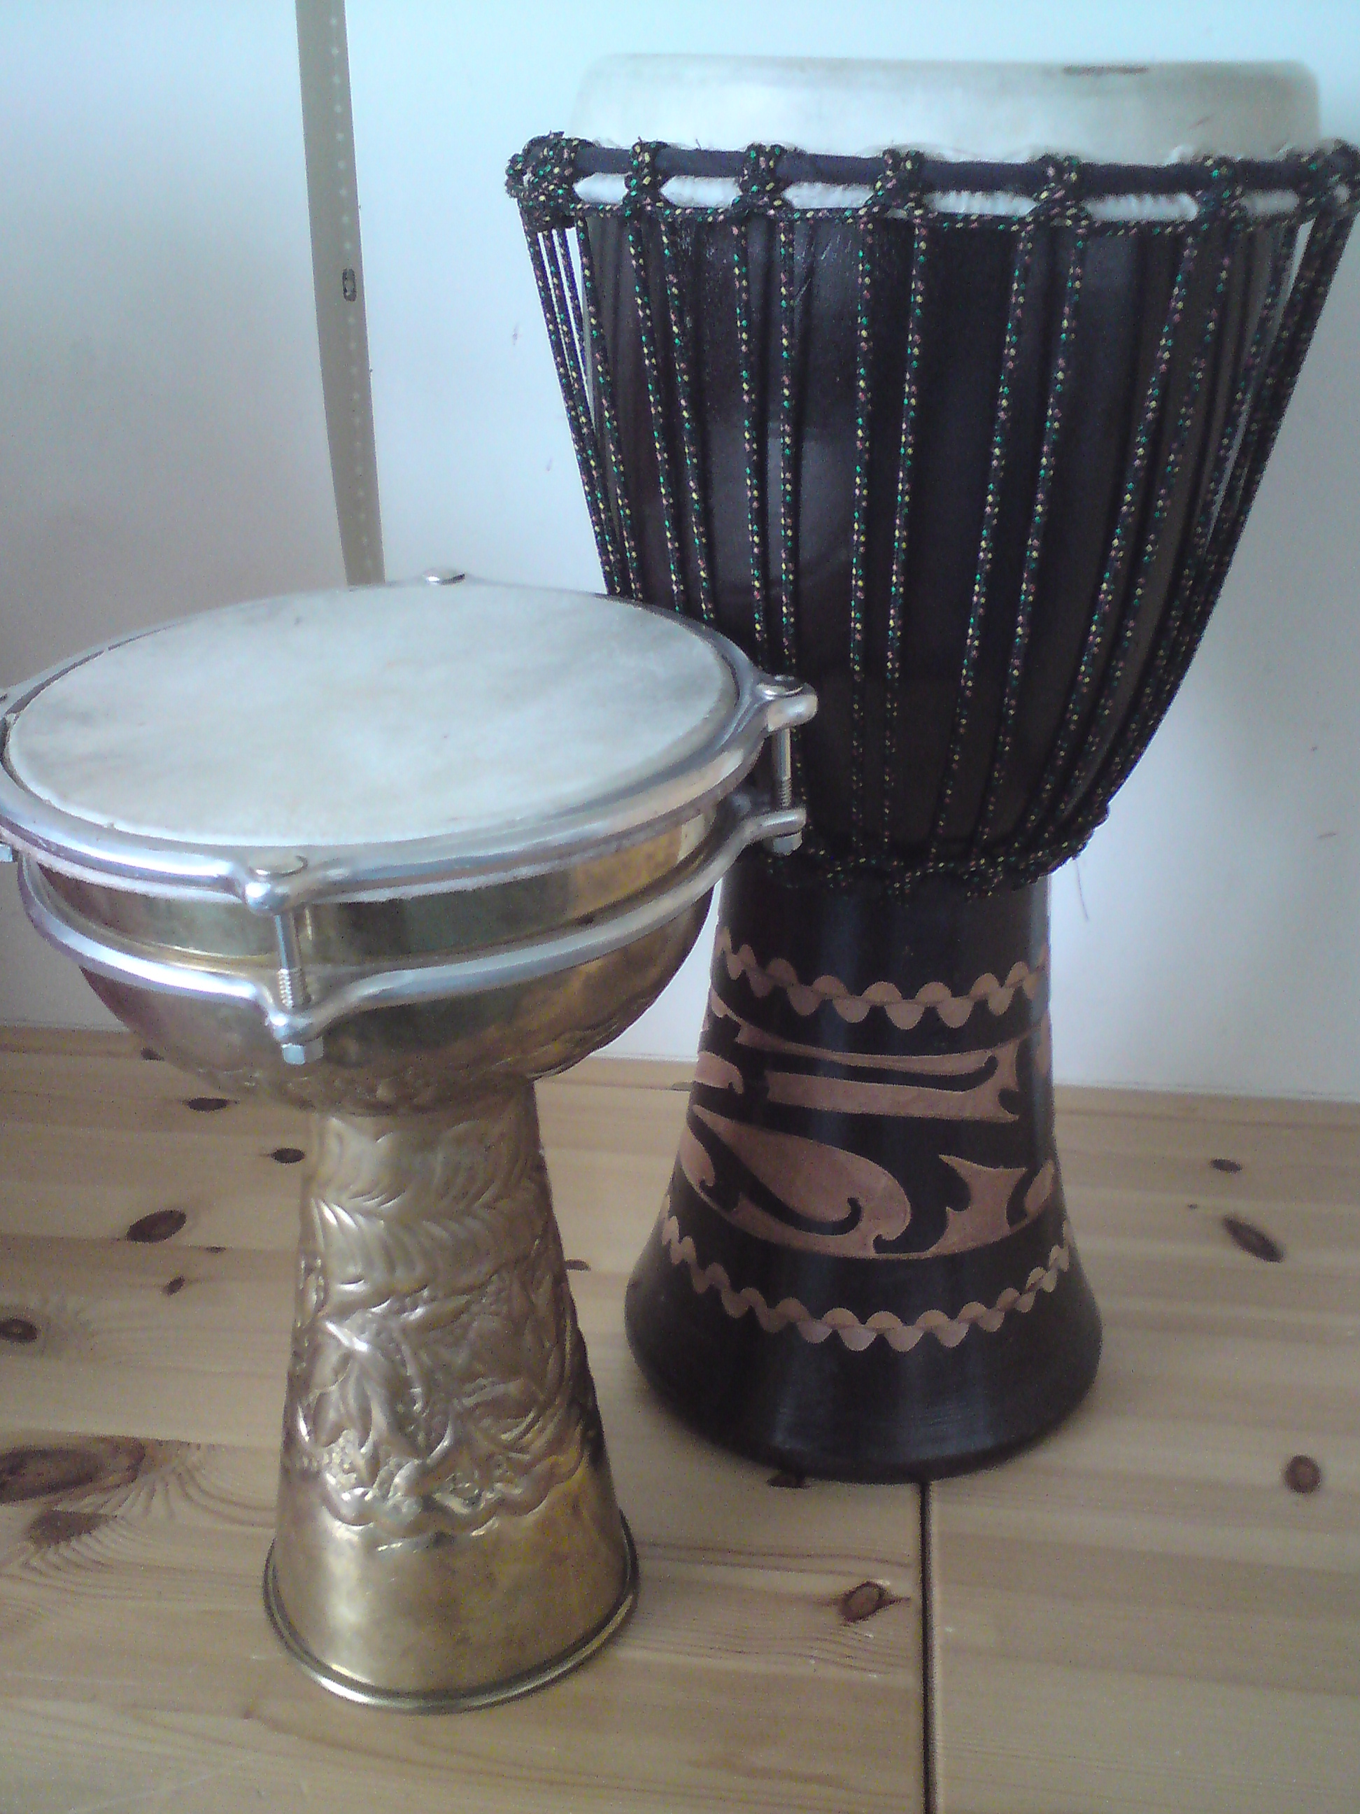

1. What is Music Therapy?

Music therapy is a psychological intervention which uses the expressive elements of music as the primary means of interaction. A person-centred approach is commonly used, to develop a therapeutic relationship. Music therapists can also deliver goal driven treatment programmes (see ‘How can music therapy help neuro disabilities?). It is through the developing relationship between therapist and client that changes occur, which influence the client’s emotional well-being.

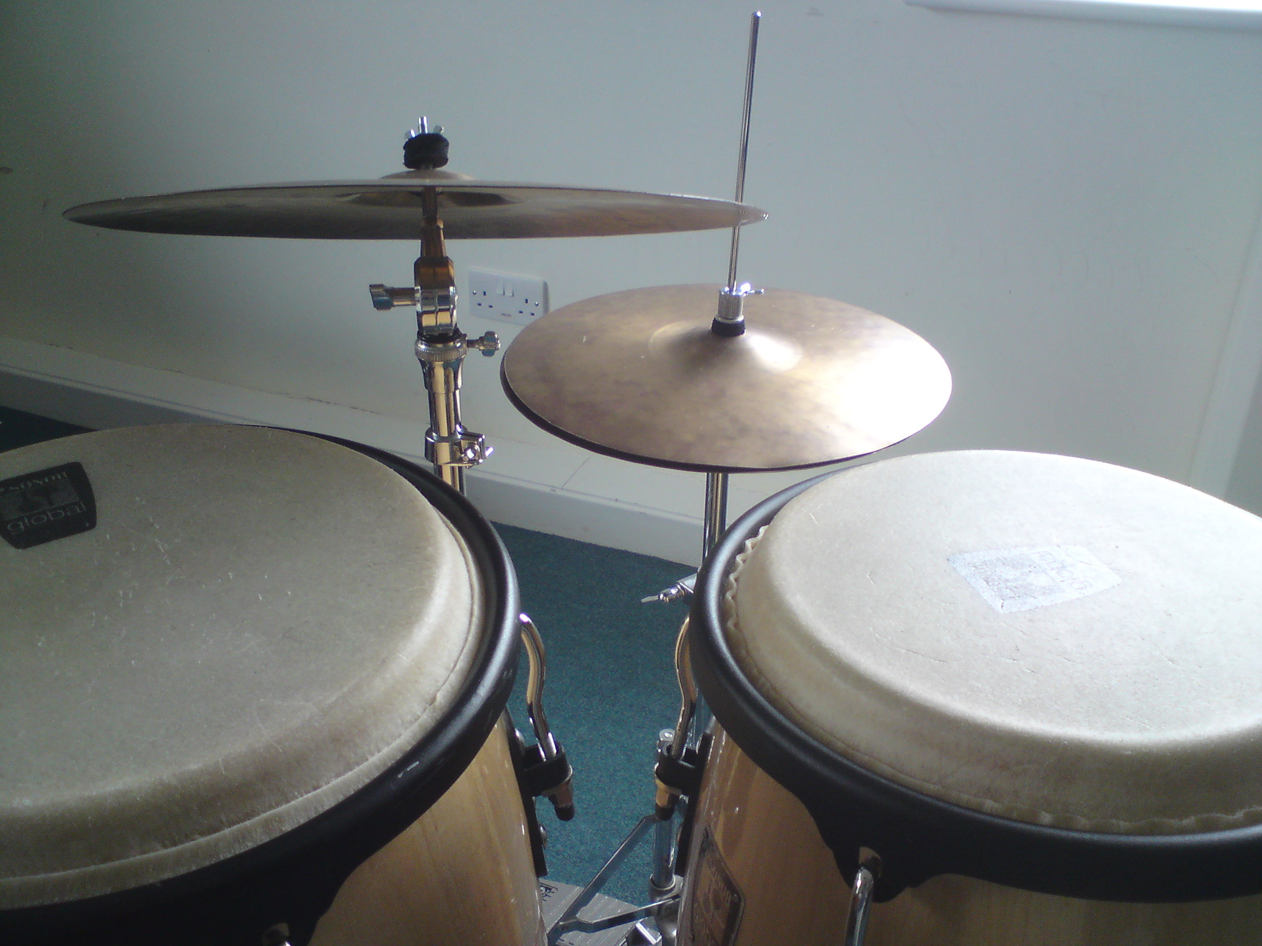
Music therapists are skilled in attentive and analytical listening, responding in a unique way to enable people of all ages and abilities to interact in their own musical language at their own level and pace.

The aims of music therapy are neither educational nor musical; clients do not have to be able to play an instrument or to enjoy music in order to benefit from music therapy. Music therapists work predominantly on developing communication, social and emotional skills.

2. What happens in a Music Therapy session?

Clients are free to play a wide variety of musical instruments in the music therapy room. There is no right or wrong way of playing. The therapist will support clients to explore the instruments in a way that is meaningful to them. Through this exploration, a means of communication is developed. Computers and music technology can also be used to help clients to access sound and music making. Using this equipment can be motivating and engaging for certain clients, as it offers contemporary sounds and can also directly address cognitive needs. Music technology can also be used to record songs that have been worked on in sessions.
For some clients, songwriting will address emotional and psychological problems very effectively, for others free improvisation may be more appropriate. The therapist will guide this. Sessions take place once a week and last up to 40 minutes. A course of therapy usually lasts between six and twelve months, but the length of each intervention will be determined following assessment and in discussion with client and/or carers.
3. How can Music Therapy help people with mental health difficulties?

Music therapy is an effective alternative to more standard forms of counselling and psychotherapy. It is well suited to clients who find it difficult to connect, express or differentiate between their emotions, or who find it difficult to communicate in any way. The opportunity to play spontaneously on the instruments with the therapist enables clients to channel their emotional energy safely. This can reduce stress, frustration and tension, so enhancing emotional wellbeing.

4. How can Music Therapy help someone living with a neuro disability?

Music is processed in many parts of the brain, which makes it an excellent tool for people living with an acquired brain injury or a neuro-degenerative condition such as dementia or Parkinson’s disease. Individual and group programmes can be devised for assessment, neuro-rehabilitation and quality of life. These aspects can be addressed by adopting the following approaches:

Compensatory: Using music to compensate for losses, in conjunction with tools such as memory/communication aids.
Psycho-social emotional: Using music to enable emotional expression, engagement in social interaction and adjustment to disability.

Restorative: Using music to regain skill and function, for example speech, movement, cognition.

5. How can Music Therapy help someone with a social and communication disorder?

Social interaction: Music
therapy is based on forming a relationship between client and therapist. This can be a helpful way to explore the idea of relationship, in a safe and non-intrusive environment.

Communication: Music provides an additional form of communication. The therapist attends closely and responds to the client in a way that encourages and values further communication. This can be verbal or non-verbal.

Imagination: Music motivates clients to engage in a naturally creative, imaginative process, with the support of their therapist. Clients often move away from a ritualistic use of instruments to a more flexible and creative use. This can lead to the development of less rigid
thought and behaviour patterns.
6. How can Music Therapy help someone with a learning disability?

Music therapy provides a unique method of communicating which is suitable for those with limited expressive or receptive communication skills. Regular engagement in music making, at the client’s pace, can greatly enhance communication skills, social awareness, emotional well-being, cognitive function and coordination.

7. How can Music Therapy help someone with multi- sensory impairment?

Music therapists work with all
aspects of sound, including
vibration. Clients with complex, profound and multiple learning disabilities, hearing impairment, multi-sensory impairment or who are deafblind, can access music
therapy at their own level and
pace.

8. What changes will be seen?

Changes in specific areas of difficulty, as stated on clients’ referral forms and observed in
assessment, should be apparent after a course of music therapy. Short, mid and long-term goals can be set and monitored for clients with neurological impairment. People receiving music therapy frequently report raised levels of confidence and self-esteem. Clients may feel more relaxed, exhibit greater self-control and their social and interactive skills may be improved. Above all, there should be a change in emotional well-being. Music therapists may ask to video sessions in order to closely observe clients responses and progress. Assessment forms will be used to evaluate change.

9. Will clients enjoy Music Therapy?

Most people are very motivated to attend their music therapy and enjoy the sessions. As with any therapy, there can be certain aspects which are challenging. The therapist monitors all responses and will sensitively work through any difficulties that arise for each client.

10. Where will it take place?

Music therapists work in care homes, hospitals, hospices, prisons, day centres, acute and post acute rehabilitation centres, schools, children’s centres, private homes and at the Child Development Centre in Kempston. Music therapy always works best in an uninterrupted environment.

