Music Therapy

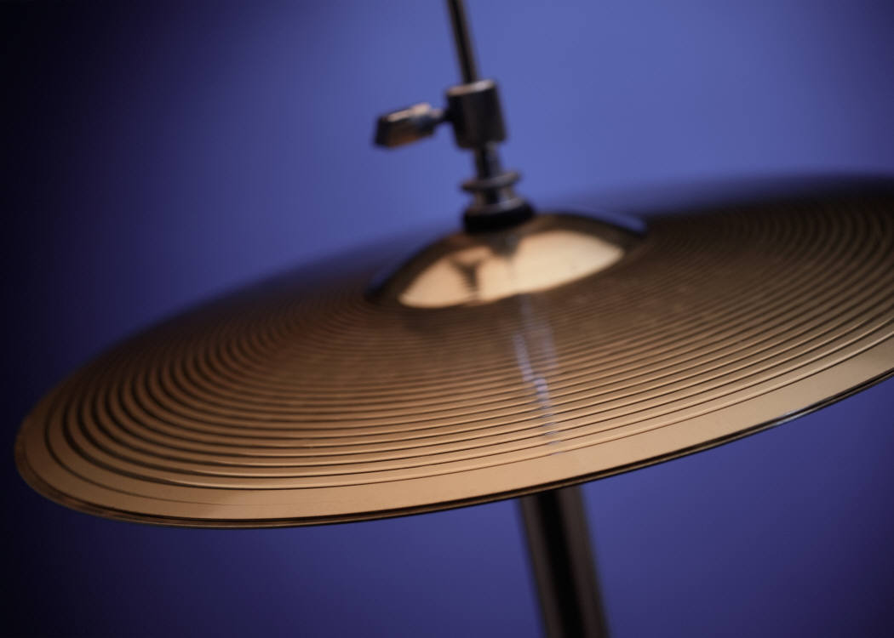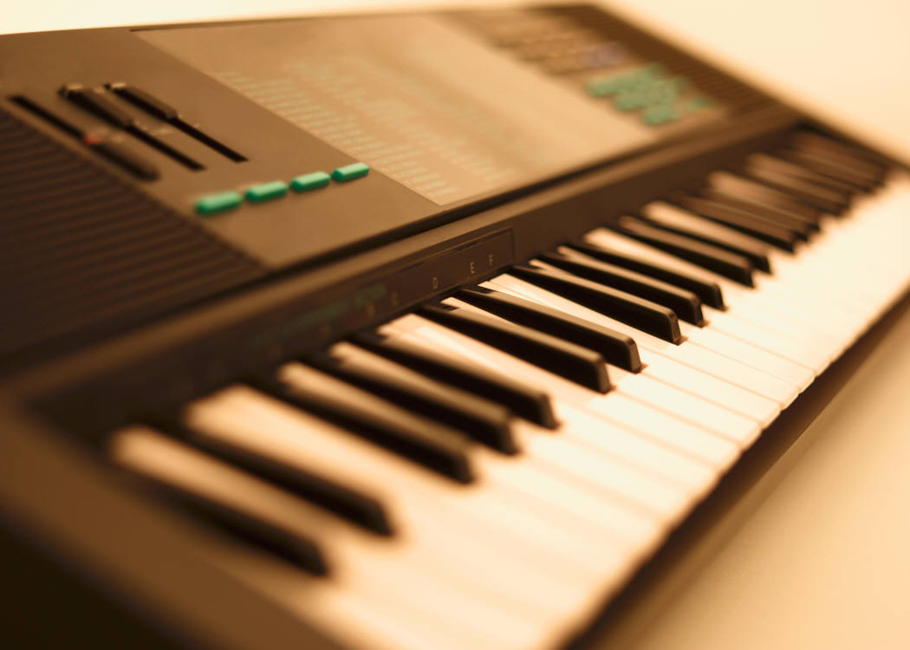

What happens in Music Therapy?
Your Music Therapist will get everything ready for you before your session starts. In the Music Therapy room there will be drums, cymbals, guitars, keyboards and smaller instruments. You can choose which instruments to try and the Music Therapist will work with you. You don’t have to be good at music and it can be fun trying out lots of different things. It will probably be just you and the Music Therapist in the room. It is not a lesson; it is your own private space where you can be yourself. When you feel settled and confident with the therapist, you may want to spend some of the time talking. This is up to you; it can be helpful if you have any worries. There is no pressure in music therapy and no rights and wrongs.

What will I do?
You can play any of the musical instruments in the Music Therapy room as quietly or as loudly as you want. There is no right or wrong way to play. You might want to try out the sounds you can make on the instruments, make up some music with the Therapist, or do something else like song writing or using a computer music programme. During the Music Therapy session you can be in control of what happens.

What will the Music Therapist do?
Your Music Therapist will be in the room with you all the time and will help you. He/she will listen to you and see what you would like to do. Your Music Therapist may want to video your session to look at what you do together and get some good ideas for the next session. He/she will ask your permission and talk to you before using the video camera.

Where will it be?
Your Music Therapy session will take place in a room that is private. Hopefully you won’t be interrupted, so that you can really concentrate on what you are doing.

How long will it last?
Each Music Therapy session usually lasts 30 - 45 minutes. Your session will be at the same time each week and you might keep coming for a year or more if you want to. Your Music Therapist will help you to decide when you are ready to stop coming.

Why me?
Music Therapy can help you if you have had a difficult time and feel upset. You might be trying not to worry about it. Playing music or talking together can help you to express yourself. Even without talking about things, music therapy can help you feel better.

